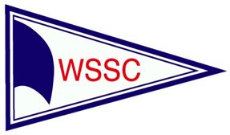 West Shore Sail Club
Presents the
Doublehanded Race
Saturday, June 20, 2020

Race Start: 10:00 am

Addendum
9.0 FINISH

9.1 The finish shall be a line between a Orange ball buoy approximately, 1/2 nm from the Toledo Beach Marina Outer entrance, and an orange flag at the break wall on shore just south of entrance. All finishers shall leave the Toledo Beach Marina break wall to starboard. If there is not a buoy present, the line will be from Toledo Lighthouse keeping less than a 1/2 nm from the Toledo Beach Marina.

9.2 To assure the best possible accuracy in timekeeping, after dark, call out your sail number and illuminate your sail as you approach the finish line. It is the responsibility of each yacht to know the time you finish and the yachts finishing before and after you. KEEP A RECORD AND CONTACT THE RACE COMMITTEE IF YOU FIND A DISCREPANCY.

9.3 The race committee will try to display a strobe light or other identifying light on shore after dark.

9.4 The race committee boat will remain on station until 1900 hours GPS time (7:00 PM). The committee boat will not take the time of any yacht finishing after 1900 hours GPS Time (7:00pm. One yacht finishing in a class before the time limit expires constitutes a valid race for that class.

